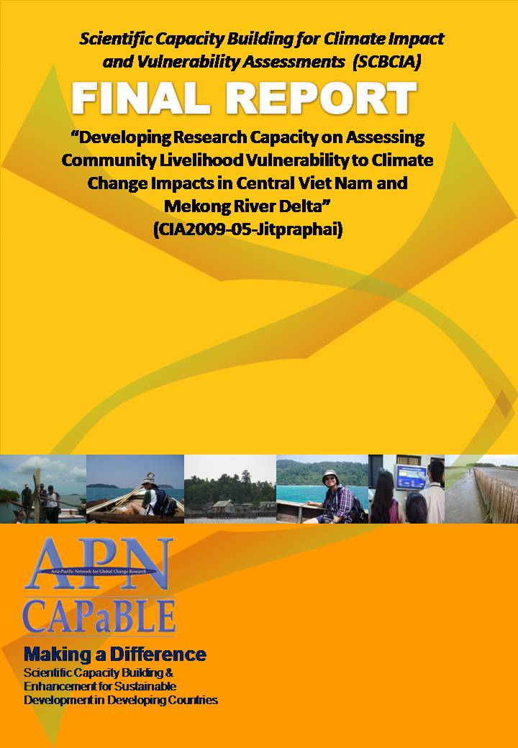

**Project Reference Number: CIA2009-P05-Jitpraphai**

**Final Report submitted to APN**

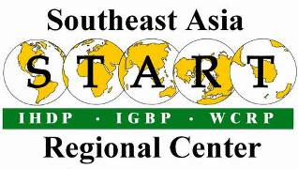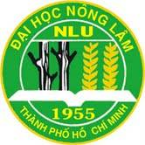

**PROJECT LEADER**

**Dr. Somrudee Jitpraphai**

**Southeast Asia START Regional Center**

**Chulalongkorn University**

**Bangkok, Thailand**

**somdeem@yahoo.com**

**PROJECT COLLABORATORS**

Mr.Suppakorn Chinvanno, Southeast Asia START Regional Center, Thailand, suppakorn@start.or.th

Dr. Le Anh Tuan, Can Tho University, Vietnam, letuan@ctu.edn.vn

Dr. Nguyen Kim Loi, Nong Lam University, nguyenkimloi@yahoo.com

**©Asia-Pacific Network for Global Change Research**

**PAGE LEFT INTENTIONALLY BLANK**

**OVERVIEW OF PROJECT WORK AND OUTCOMES**

**Non-technical summary**

Climate change and its impact are great concern for the countries in the Southeast Asia, especially Vietnam, which according to Intergovernmental Panel on Climate Change’s assessment report, would be highly vulnerable to the impact of climate change. Preparation to climate change would need knowledge and information on how various areas and sectors in Vietnam would be vulnerable to climate change. This would require a lot of assessment activities in the near future; however, there are small numbers of researchers who experience with the assessment process. This project aims at developing/enhancing research capacity on the issue by engaging 2 groups of researchers from Can Tho University and Nong Lam University in a workshop conducted by SEA START RC to develop framework for assessing community livelihood vulnerability to impact of climate change, which based on experience of SEA START RC in climate change study in the region over the years. Case study on vulnerability assessment was conducted in the Mekong River Delta and Central Vietnam as an exercise, which served not only practice on assessment process in the local community but also the test of method as well as raising awareness to local stakeholders on climate risk which may change its profile from global warming in the future.

**Objectives**

The main objectives of the project were:

1. To develop and enhance research capacity at 2 newly established research centers at 2 universities in Vietnam to gain experience on the use of future climate projection data to assess climate change risk of key sectors under context of the study site.
   * Research Institute for Climate Change – Can Tho University (DRAGON Institute -Mekong)
   * Research Center for Climate Change (RCCC) of Nong Lam University
2. Understand the integrated approach of assessing community livelihood vulnerability to impact of climate change.

**Amount received and number years supported**

The Grant awarded to this project was:

US$ 28,500 for 1 Year 2009/2010:

**Activity undertaken**

1. First training workshop at Can Tho University to discuss method and scope of assessment and implementation plan on the pilot study and field trip to visit study sites during 24-29 July 2010. The discussion during the workshop was focused around the following topics:
   * Current risk from climate and socio-economic change and local response from local perspectives;
   * interaction among key sectors in the study sites;
   * Plausible future of the society based on socio-economic scenarios;
   * Framing future risk and vulnerability profile of the sectors & society at the selected study site.
   * To An Giang Province in Mekong River Delta
   * To Quang Nam Province in central region of Vietnam
2. Case study exercise in Mekong Delta area – activity at study site during August- November 2010.
   * Field survey at Chau Phu district during 18-19 August 2010 to discuss with sub-Department of Natural Resource and Environment (DONRE) about survey purpose and prepare local stakeholders to participate in the PRA activity, and also collect secondary data on rice production, population, some disaster report. Moreover, discussion with sub-DONRE also include social and economic development plan / map and statistical data of the study site as well as present overview on climate change and adaptation concept to local official and stakeholders / introduce our study objectives.
   * Participatory Rural Appraisal (PRA) activity and data collection in An Giang Province during 21-22 August 2010. Group of farmers were invited to the PRA activity. Group of 34 farmers from Binh Long commune and 31 farmers from Phu My commune had participated in the PRA to perform focus group discussion about historical disaster in order to produce risk map, anomaly climate pattern, impact of climate on their farming production and livelihood, local adaptation to climate risk, collect suggestion from farmers on future policy to address climate risk and improve resilience of farmer community to climate impact.
   * Questionnaire interview during the same period as PRA activity with local people in Chau Phu district to collect household information and risk to natural disasters as well as assess their coping capacity (individual interview).
   * Data analysis in Can Tho University during the month of September – October.
   * Briefing on climate change risk and adaptation assessment to local staff – technical staff in DONRE – Chau Phu district, An Giang province in October 2010.
3. Case study exercise in Central Vietnam – activities at study site in Quang Nam province, during July – November 2010.
   * Field survey during 12-13 July and meeting with DONRE in Quang Nam province to gain approval for field study as well as to raise awareness on climate change and also collect secondary data e.g. map land-use and other social-economic data.
   * Field visit during 27-29 July to gain understanding on climate related disaster, especially landslide. Also interview the household who had survived landslide and those who had relocated to new settlement.
   * Participatory Rural Appraisal (PRA) activity during 31 Aug. – 1 Sept. by researcher team from both Nong Lam University and Can Tho University, which focused on climate risks, response of local stakeholders, government policy and collect disaster record documentation.
   * Questionnaire interview during the same period was conducted together with sub-DONRE staff, which focuses on household information and risk to natural disasters as well as local community’s coping capacity to risk (individual interview).
   * 29-30 Nov. collect additional data on land-use and conduct ground-truth survey for hydrological model set-up.
   * Data analysis at Nong Lam University during the month of September – November.
4. Follow-up meeting during 1-2 October at Nong Lam University. The expert team from SEA START RC discussed with research teams from Nong lam University and Can Tho University to review field data collection, activities conducted in the field assessment and prepare technical paper outline.
5. Synthesis meeting during 26-27 December at Nong Lam University. The expert team from SEA START RC reviewed data analysis result, assessment outcome and summary and prepare final report (technical & financial).

**Results**

This project has enhanced research capacity for 2 groups of scientist from 2 universities in Vietnam for the upcoming climate change vulnerability and adaptation (V&A) assessment which might be taken in the near future. The framework of the climate change V&A assessment which based on holistic view and focused on current climate related risk that affects livelihood of the rural community was introduced in this project has broaden the frame of thought on the V&A assessment from conventional approach which take climate change as a single issue and as initial point in the assessment of risk, vulnerability and adaptation based on sector basis, without concerns on interaction among sectors in the community. The pilot assessment under this project exercised the integration of other socio-economic conditions and holistic view of the community into the vulnerability assessment process which would give more realistic picture of community livelihood vulnerability to climate change impact. The assessment exercise conducted at the pilot study sites also raised awareness on the local stakeholders as well as local government officials on the climate change issues in the local context. Moreover, the result from the pilot study in 2 areas can be used as foundation or initial step to trigger policy toward full assessment in the future.

**Relevance to APN’s Science and Policy Agenda**

The proposed activities directly address main focus of SCBCIA in building scientific capacity of developing nation to conduct climate impact and vulnerability assessments by accessing to the necessary data and method to evaluate risk of climate change of the community in the selected study sites. The outcomes would include experienced researchers as well as lesson learned, which will be useful in supporting national strategic planning to cope with climate change. These lessons learned could also be used by the international community. Regional global change study collaboration is also strengthened through activities under this project by engaging with START research network. The activity on field assessment in the case study at selected sites as well as joint synthesis workshop among scientists, key community leaders, and provincial administrative officials has raised awareness of climate change risk and adaptation in the local context.

**Self evaluation**

The research teams have successfully adopted integrated assessment concept in community livelihood vulnerability to climate change which is rather new concept and gain experience in working with local stakeholders in assessing climate risk concern and adaptation. Research capacity on climate change study has been enhanced in the 2 newly established research centers in the Can Tho University and Nong Lam University, with 8 researchers directly engaged in the workshop and case study exercise with some junior scientists involved as research assistants. The case studies, which was conducted as exercise to test the assessment framework, have served as initial step toward full assessment for policy planning in the future.

**Potential for further work**

More assessment with integrated multiple social and economic development scenarios, which includes scenarios development exercise with local stakeholders and government agencies, should be further planned for the study sites. The dialogue on mainstreaming climate change into provincial development plan would be an appropriate follow-on activity.

**Publications (please write the complete citation)**

Chinvanno, S., Le Anh Tuan and Nguyen Kim Loi, 2011. Assessing Climate Change Impact and Rick in Vietnam: The initial pilot study in Mekong River Delta and central Vietnam. Bangkok: Southeast Asia START Regional Center Technical Report. *(In print)*

**TECHNICAL REPORT**

**Preface**

Being one of the most vulnerable countries to climate change, Vietnam would require extensive study and assessment on risk, vulnerability and adaptation to climate change on various sectors and areas. Limited local research capacity would require capacity development and enhancement as preparation for the upcoming climate change study in the near future. This project has engaged group of researchers from 2 universities, Can Tho University and Nong Lam University, to gain knowledge on integrated approach on community livelihood vulnerability and adaptation to climate change as well as case study exercise in at the local community, which not only served as practice and exercise on risk analysis and vulnerability assessment framework, but also to raise awareness on climate change with local stakeholders, which has established foundation for future climate change policy planning for the community.

**Table of Contents**

**1.0 Introduction**

Assessing climate change risk, vulnerability and adaptation is of great concerns for Vietnam in order to gain information to assist proper policy planning. However, with limited number of experienced scientist, the assessment on climate change impact, vulnerability and adaptation has been conducted in broad view and focused on sector basis, without taken interaction among sectors in the community into consideration. However, in many cases, climate change adaptation would need to be initiated at the community level, therefore, the assessment would need to be taken with the community and take local context on community’s livelihood, climate risk profile and how various sectors in the community would interact under the effort to adapt to climate risk into consideration in order to properly plan for community-based adaptation to climate change.

This project aims at filling research capacity gap by build and enhances research capacity at 2 newly established research centers at 2 universities in Vietnam to gain experience on assessing community livelihood vulnerability to climate change impacts. The 2 research centers as mentioned are:

* Research Institute for Climate Change – Can Tho University (DRAGON Institute -Mekong)
* Research Center for Climate Change (RCCC) of Nong Lam University

The researchers who are engaged into this project had learned the holistic approach on developing climate change vulnerability and adaptation assessment framework and the use of future climate projection data to assess climate change risk of key sectors under context of the study site. Moreover, case study exercise, which is the assessment on climate risk and vulnerability at the selected study sites, allows the researchers to test and learn assessment process in real life situation. In addition, by engaging local stakeholders in the assessment process, based on participatory rural appraisal (PRA) method, also raised awareness on climate change risk among local stakeholders and local policy makers as well as local government officials, which help establish foundation for developing science-policy dialogue in mainstreaming climate change into rural development plan in the future.

**2.0 Methodology**

The assessment on community livelihood vulnerability to climate change impacts, which is carried out at the selected study sites in the Mekong River Delta and central region of Vietnam in this project is based on assessing key concerns on climate risk from local community context, which use historical data analysis and participatory rural appraisal (PRA) technique to determine how sectors/groups in the community may expose and sensitive to climate impact. Then, adaptive capacity of each group is assessed by personal interview and focus group discussion through PRA process. Future risk from climate change is determined by analyzing data from future climate projection which is result from regional climate model as well as other mathematical model used to analyzed impact of climate change, i.e. hydrological model, which use data from regional climate model as input. Then, adaptation to climate change impact is assessed by focus group discussion among local stakeholders in the PRA process. The methodology in the assessment is summarized as following diagram (Figure 1).

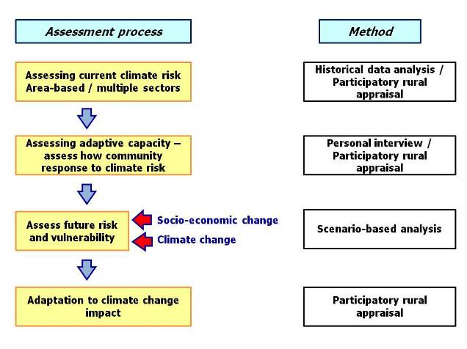

*Figure 1: Framework in assessing community livelihood vulnerability and adaptation to climate change impacts*

**3.0 Results & Discussion**

**3.1 Assessment on community livelihood result at An Giang Province, Mekong River Delta**

The Mekong River Delta (MD) in Vietnam is the most downstream part of the Mekong River Basin before its water flowing to both the East Sea and the Gulf of Thailand. This Delta is the largest agriculture and aquaculture production region of Vietnam. The MD is the area where the impacts of climate change can be most severe. Historically and practically, the people of the Delta has settled and cultured densely along the river and canal banks. Human life, agriculture and aquaculture production, domestic water supplies in the Delta depends highly on the meteorological and hydrological regime. This livelihood condition is sensitive and could be threatened by changing climate and hydrological cycle. Future climate projection from regional climate model indicates that the Mekong River Delta region tends to be warmer in the future with longer and drier summertime. Seasonal pattern could be altered under influence of global warming. Moreover, changing in the climate pattern in the upstream region of the Mekong River also affect the flood regime of the Mekong Delta, where the boundary of future flood could expand to wider coverage.

An Giang is an upstream province in the southwestern part of the MD. It is partially located in the Long Xuyen quadrangle, sharing a 104-km length border with Cambodia. An Giang province has a total natural area of 353,676 hectares, in which 280,658 ha of agricultural land, 14,724 ha of forest land. An Giang province has a total population of 2,149,184 people (2009). The population density of An Giang is 608 persons per square kilometer.

Main livelihood of the people in Mekong River Delta, particularly in An Giang province, primarily based on agricultural activity, especially rice farming, aquaculture, which makes them highly expose to climate imapct. An Giang is considered not only as the most rice production in the MD but also the highest rice production province in the whole Vietnam. Each year, An Giang distributes more than 3.5 million ton of rice for the country. There are two main rice crops in An Giang: the Winter – Spring rice crop from December to March and the Summer – Autumn from May to August. The third rice crop, i.e. Autumn – Winter, is found in some closed dykes areas where the pumping irrigation systems inside the dykes are available. The rice production in these rice crops is presented in Figure 2.3. An Giang is also a province having the highest catfish production compared in the whole Vietnam.

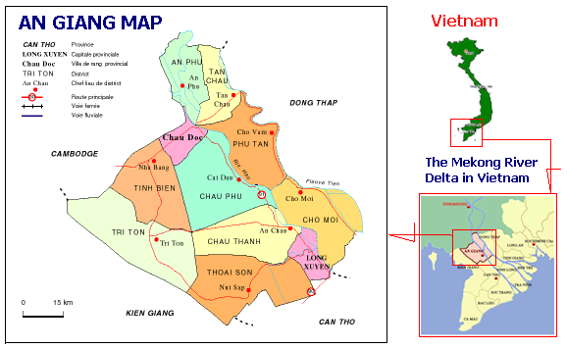

*Figure2: An Giang Province, Mekong River Delta*

**Key concerns on climate driven risks: PRA result**

Flood is annual phenomenon in An Giang affecting prolonged deep inundation, river bank erosion, and transportation difficulties. Even though extreme high flood case causing the agricultural production and livelihood damages as in the flood of the year 2000, floods in An Giang provides positive effects as ecological function. Positive effects of flood are sedimentation, fisheries, other food products, leaching toxic in acid sulfate soils, rats and insects elimination, provision of fresh water, refilling of groundwater, protection of forest and provision of ecosystem services.

There is a currently worry issue in the flood situation, in An Giang in particular and in the Mekong River Delta in general, that the flood volumes become worse and worse in last 10 years. The peak water levels trend is decreasing, especial in this year (2010), on October 1st, 2010 the peak water level is only 211 cm in Chau Doc, and considered very low if compared the normal flood level as 350 cm (Figure 3). Low flood in 2010 combined with bank erosion phenomenon along Chau Phu’s river bank is very serious.

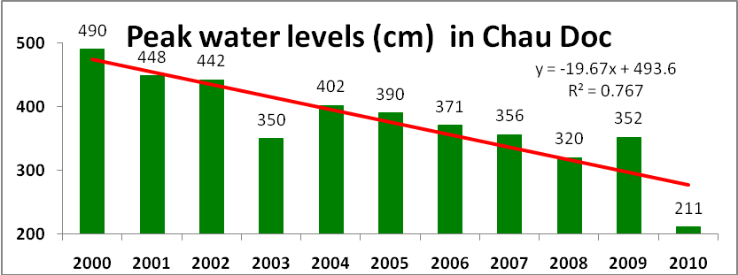

*Figure 3: Peak water level trend line in Chau Doc, An Giang*

Result from focus group discussion, trend of change in key climate related risk can be summarized as follows:

|  |  |
| --- | --- |
| **Key concerns on climate related risk** | **Trends** |
| Dry duration prolonged | **🡽** |
| Wet duration shorted | **🡾** |
| Annual mean temperature | **🡽** |
| Heat waves | **🡹** |
| Precipitation in critical season | **🡾** |
| Abnormal rainfall in wet season | **🡽** |
| Upstream floods | **🡻** |
| Sedimentation | **🡾** |
| River bank erosion | **🡹** |
| Drought | **🡽** |
| Abnormal strong wind (Whirlwind) | **🡽** |
| Abnormal weather in vegetable crop duration | **🡺** |
| Abnormal weather in catfish crop duration | **🡺** |

Notes: **🡽** Increasing

* High increasing
* Decreasing
* High deceasing

**🡺** Unchanged

**Climate change and future climate risk**

According to data analysis based on climate change scenarios from future climate projection based on dynamic downscaling of ECHAM4 GCM A2 emission scenario from SEA START RC (Figure 4-8), there would be changing in trend of climate related risk over the next 3 decades, which can be summarized as follow (Figure 9):

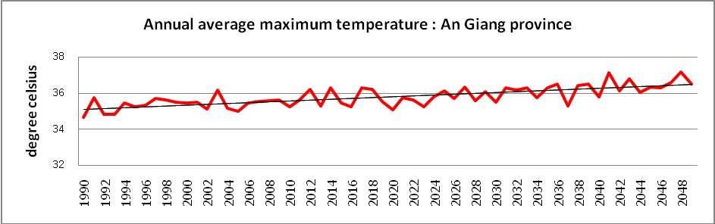

*Figure 4: Trend of change in annual average maximum temperature – An Giang province*

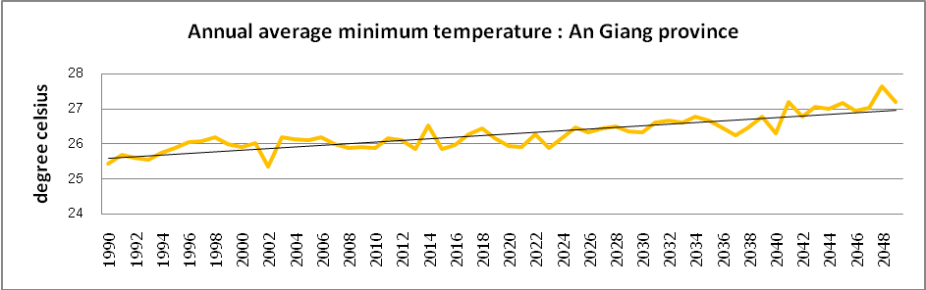

*Figure 5: Trend of change in annual average minimum temperature – An Giang province*

|  |  |
| --- | --- |
|  |  |

*Figure 6: Change of rainfall patterns in An Giang province*

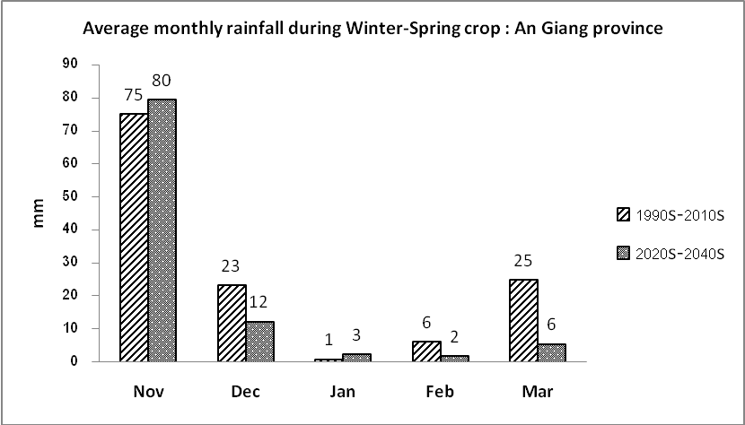

*Figure 7: Change in average monthly rainfall during Winter - Spring crop in An Giang province*

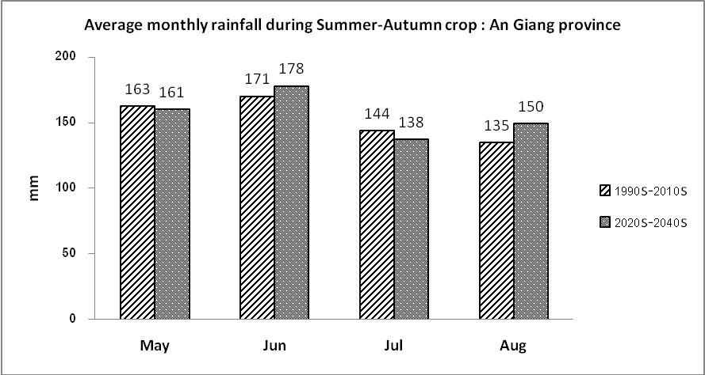

*Figure 8: Change in average monthly rainfall during Summer - Autumn crop – An Giang Province*

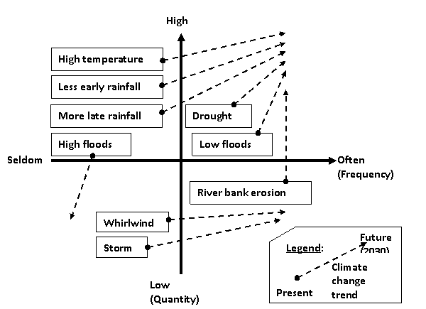

*Figure 9: Trend of change in magnitude (vertical axis) and frequency (horizontal axis) of climate driven risk in the An Giang province*

**Community livelihood vulnerability and adaptation to climate change impact**

From focus group discussion in the participatory rural appraisal process, which engages various local stakeholders to share experience and opinion on climate change risk and adaptation, the vulnerability of key sectors in the community in An Giang province can be summarized as follow:

|  |  |  |  |
| --- | --- | --- | --- |
| Category | Vulnerabilities | | |
| Exposure | Sensitivity | Coping Capacity |
| Rice production | Less rainfall and river discharge leads to lower rice yields and production | High | Pumping more water /Saving water;  Building closed dykes;  Additional chemical fertilizer;  Improving rice varieties;  Adjusting cropping calendar |
| Fish production | Less catching fish due to low flow from upstream;  Heat waves may affect catfish yield | Medium | Young fish “finger seeding”;  Improving fish ponds with air circulation pans;  Changing water regularly  Planting trees along pond edges |
| Local likelihoods | High temperature affecting people's health and daily jobs | Medium | Easy for making brick, fish drying;  Loan money from credit funds;  Mitigation onto city;  Health care promotion |
| Transportation  and infrastructure | River bank erosion leading more difficulties on waterway transportation | Medium to High | Bank protection by sand bags;  Moving houses |
| Ecosystem | Poor sedimentation;  Water pollution;  Lower floods;  High temperature | High | Applying organic fertilizer;  Storing water in ponds, jars, reservoir;  Awareness education;  Planting more trees |

**Conclusion**

The case study exercise of the research team from Can Tho University, which had carried out in the An Giang province, Mekong River Delta, based on participatory rural appraisal process and focus group discussion(see Figure 10), shows how various sectors might be vulnerability to climate change impacts and some adaptation options to cope with future risk has been identified. The field assessment activity has also raised awareness on climate change among local stakeholders.

|  |  |
| --- | --- |
|  |  |
|  |  |

*Figure 10: Focus group discussion on community livelihood vulnerability to climate change impact at Cho Phu district, An Giang province, Mekong River Delta*

**3.2 Assessment on community livelihood result at Quang Nam Province, Central Vietnam**

Dong Giang District is one of eight mountainous districts located in western part of Quang Nam province and upstream Vu Gia watershed– the central Vietnam (Figure 11), with 107º 30’ to 107º56’ longitude and 15º35’ to 16º10’ latitude and 70 km west of Da Nang city. The region occupies an area of approximately 81,000 ha as shown in Figure 11. The Dong Giang district has been divided into 10 villages and 1 town. Dong Giang locates in mountainous area associated with small valleys and distributed by small and middle stream networks. The area is classified into 3 categories by height, i.e. the area of higher than 1000m over sea level accounts for approximately 22,600 ha which is 27.81% of the total; from 500m to 1000m height is about 38,400 ha ( 47.25%) and below 500m is 24.94%.

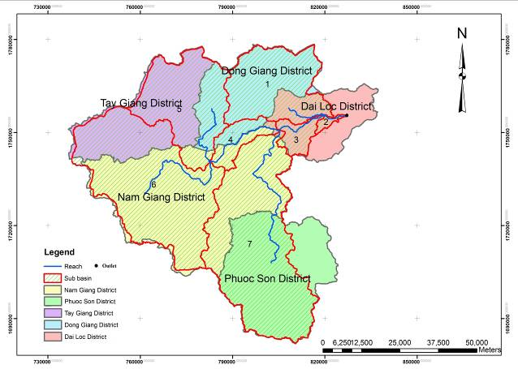

*Figure 11: Vu Gia watershed in Quang Nam province map*

Statistically, the population of the district was 23,635 people in 2008, of which 73.21% were C’tu ethic-a minor group and the rest was Kinh people. Eighty percent of the local population relied on agricultural production and forestry activities for their livings. The value of Dong Giang district has been based on its diverse natural, cultural and historical resources including forest and its products, ethnic culture, etc.

On the other aspect, the area often suffers from tremendous catastrophically natural hazard causing by flash flood and typhoon. Recently, these disasters are in increasing trends. In addition to natural disasters, developing activities such as hydropower construction, road building, mining and stone exploitation have accelerate the hazard.

In terms of bio-physical characteristics, Dong Giang can be described from Da Nang city outlet to the Thua Thien Hue province border, there are intermediate mountains (400-1000 msl and more than 25 percent of slope.) covered with tropical rain forest. The outlet is Vu Gia River which flows through the downtown. In the eastern part of the study area near Da Nang City border, covered with tropical rain forest.

In 2008, agricultural sector is used 80% human resource, and contribute around 70.47% value of economic income for the district, including cash crop as rice, corn, cassava, peanut, as well as industrial tree like tea plantation, bananas, rubber, and medical plant/ herb. Animal farming is household level, it provides for sources of protein and to take use most of some other sources from household left, like local pig, local chicken are very tasty but low production, cow, water buffalo, all kinds of animal here are farming as traditional method which is use full of non- processing food supply.

Forestry average used 81,46% total area, in year 2008, it supplied 4,535 m3 timber, bamboo plant 530,000 plants for handicraft, 150 tons of rattans, bamboo shoot 185 tons, this sector contributed 21,68% for economic of the district.

Generally, physical characteristic of the area is hilly or mountainous landscapes, which is classified as a steep slope (more than 25 percent). In a context of land utilization, and a survey report of 2005 (Quang Nam Forest Department) more than 50 percent of the study area was occupied by forest. The rests of the study area were agricultural land, and unclassified land such as swamp, municipal area, and real estate.

**Key concerns on climate driven risks:**

The climate in the area is tropical monsoon and characterized by a wet and a dry season. The wet season starts from July and ended in of December but it may extents to January in the eastern part of the province in some area, during the east west monsoon. The dry season covers the remaining months of the year. The annual rainfall is about 3,600 mm. More than 80 percent of the rainfall is concentrated in the wet season. Heavy rains usually come in July and October making the water level in the rice fields near the stream rise quickly causing short-term floods. High and intense rainfall in the Dong Giang province often cause flash flood, which has increasing rapidly recently, and the damages were seriously not only to citizen property, public property but also human lost. In the year 2006, the district had record of 1,261 houses collapsed, three people died (reported by local government 2007).

From historical data analysis and participatory rural appraisal process among local stakeholders as well as local government officials (see Figure 12), the main key concerns on climate driven risk are flood and landslide that may increase in frequency and magnitude in the future under climate change. Moreover, as government has plan for numbers of hydropower dam in the district, the concern is also on the change in hydrological profile and potential sediment yield which may affect the life of dam operation.

|  |  |
| --- | --- |
|  |  |
|  |  |

*Figure 12: Participatory rural appraisal activity conducted at Dong Giang District, Quang Nam Province*

**Climate change and future climate risk**

Future climate scenario was analyzed for the Quang Nam province, based on data from future climate projection from SEA START RC, which shows trend of increasing annual precipitation in the area (Figure 13 – 14), which may cause higher flood risk and landslide in the area.

|  |  |
| --- | --- |
|  |  |
| *Figure 13: Average annual rainfall during present time and future* | |

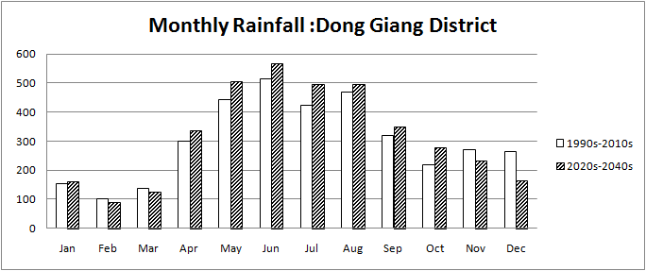

*Figure 14: Monthly rainfall in Dong Giang district, Quang Nam province*

Future climate projection data was also used as input for hydrological model, SWAT model, to analyze change in hydrological profile, especially the surface run-off and sediment yield. Result from hydrological analysis shows that change in future annual precipitation would increase both surface run-off and sediment yield of the Vu Gia watershed, which was selected as a demonstration case in the pilot case study. Detail is shown in the table below:

*The SWAT simulated statistics for Vu Gia watershed using climate scenario A (1990s) and future climate scenario B (2030s)*

|  |  |  |  |
| --- | --- | --- | --- |
| Scenario | Precipitation (mm) | Surface runoff (mm) | Sediment yield (ton/ha) |
| 1990s | 2702.95 | 54.26 | 18.28 |
| 2030s | 3371.25 | 168.04 | 76.69 |

**Community livelihood vulnerability and adaptation to climate change impact**

The participatory rural appraisal process among local stakeholders as well as local government officials was conducted to discuss plausible consequences of climate change and potential adaptation options as summarized in the diagram below (Figure 15).

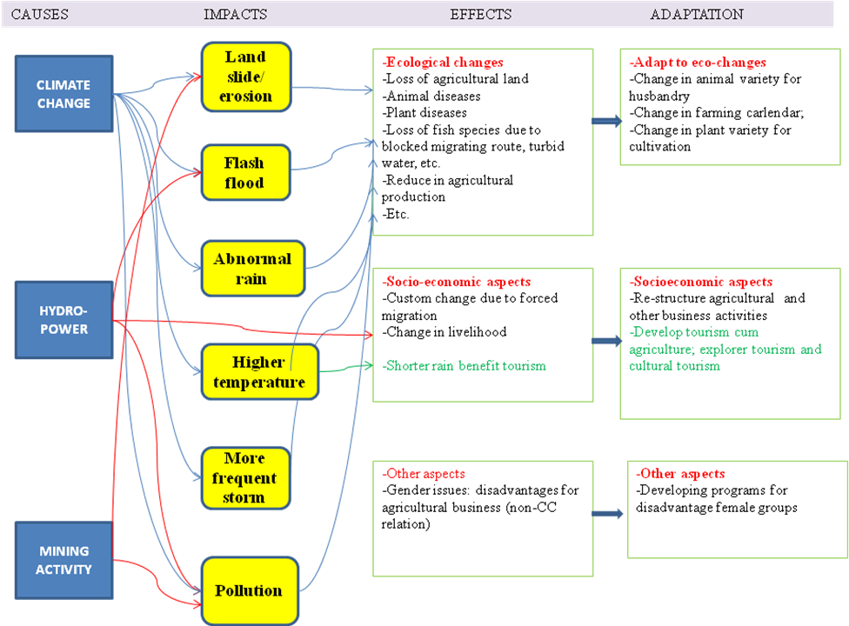

*Figure 15: Plausible consequences of climate change and potential adaptation options for Dong Giang district, Quang Nam Province*

**Conclusion**

The case study exercise of the research team from Nong Lam University, which had carried out in the Quang Nam province, central region of Vietnam, shows how future climate projection data could be used to analyze risks which local community concern. Moreover, change in hydrological regime in the future from the result of hydrological modeling also shows trend of change under future climate scenario, which may affect the planning for future hydropower dam in the province. Some adaptation options to cope with future risk were also identified. The field assessment activity has raised awareness on climate change among local stakeholders.

**4.0 Conclusions**

The main objectives of the project were:

1. To develop and enhance research capacity at 2 newly established research centers at 2 universities in Vietnam to gain experience on the use of future climate projection data to assess climate change risk of key sectors under context of the study site.
   * Research Institute for Climate Change – Can Tho University (DRAGON-Institute-Mekong)
   * Research Center for Climate Change (RCCC) of Nong Lam University
2. Understand the integrated approach of assessing community livelihood vulnerability to impact of climate change.

The activities under this project had engaged 8 scientists from 2 universities in Vietnam to gain experience in using future climate projection data in community livelihood vulnerability to climate change impacts. Case study in real-life field assessment allows the teams to practice the assessment with the selected communities with group of local stakeholders and enhance their understanding on the holistic approach in the climate change vulnerability and adaptation assessment. The case study exercise also served as awareness raising activity for the local community to aware of future climate change and adjust the mindset to start thinking of options to adapt to future change and/or adjust the livelihood or development strategy to be more resilience to climate risk. However, this project is a small scale assessment with primary objective to enhance research capacity of the scientists, therefore, some of the finding may need to be reassess using improved dataset and process in order to come up with the outcome that can be part of local development strategic planning process.

**5.0 Future Directions**

Science – policy dialogue on mainstreaming climate change adaptation into local development strategic planning for higher resilience to climate risk would need to be initiated. This would need repeated assessment on community livelihood vulnerability to climate change impacts with more integrated approach, of which interaction among sectors in the community need to be taken into the analysis and assessment process. Moreover transboundary issue across watershed would also need to be included in the planning process.

The initial team of scientists who have involved in this project would need to plan for integrating the concept in climate change study into relevant curriculum or encourage more research within the academic community in Vietnam, which would need to be centered on the community or jointly conducted with local stakeholder in the study sites. Ultimately, a formal education program with curriculum on climate change risk analysis and scenario-based planning would need to be established in the local university to create critical mass of scientist for climate change study in Vietnam as well as in the Southeast Asia region.

**References**

Arnold, J.G., Srinivasan, R., Muttiah, R.S. and Williams, J.R. 1998. Large area hydrologic modeling anh assessment part I: model development. J. American Water Resources Association 34: 73-89.

Chinvanno, S., Lueng-aram, V., Sangmanee, C., Thanakitmethawut, J., 2009. Future Climate Projection in Thailand and Surrounding Countries. Southeast Asia START Regional Center Technical Report No. 18. Bangkok, Thailand.

Dasgupta, S., Laplante. B., Meisner, C., Wheeler, D., and Yan,J., 2007. The Impact of Sea Level Rise on Developing Countries. A Comparative Analysis. World Bank Policy Research Working Paper 4136, February 2007.

IPCC (2007). Climate Change 2007: Impacts, Adaptation, and Vulnerability. The Fourth Assessment Report of the Intergovernmental Panel of Climate Change. Cambridge University Press.

Loi. N.K., and N. Tangtham. 2005. Decision support system for sustainable watershed management in Dong Nai watershed – Vietnam. Paper presented in International Seminar on “Synergistic Approach to Appropriate Forestry Technology for Sustaining Rainforest Ecosystem”, March 7 - 9, 2005, Bintulu Kinabalu, Malaysia.

Neitsch, S.L., Arnold, J.G., Kiniry, J.R., Srinivasan, R. and Williams, J.R. 2002. Soil and Water Assessment Tool. User’s Manual. Version 2000. GSWRL Report 02-02, BRC Report 2-06. Temple, Texas, USA.

Somura, H., Hoffman, D., Arnold, J.G., Takeda, I. and Mori, Y. 2009. Application of the SWAT Model to the Hii River Basin, Shimane Prefecture, Japan. Soil and Water Assessment Tool (SWAT) Global Applications. World Association of Soil and Water Conservation. Special Pub. No.4.

UNDP, 2004. Adaptation Policy Frameworks for Climate Change: Developing Strategies, Policies and Measures. Cambridge University Press, Cambridge, UK.

**Appendix**

**Conferences/Symposia/Workshops**

**Workshop on Climate Change Vulnerability and Adaptation Assessment Framework and study sites visit**

The workshop was conducted at Can Tho University during 24-25 July 2010 and field visit to study sites was conducted during 26-29 July 2010

Workshop agenda:

|  |  |
| --- | --- |
| ***24 July 2010*** | |
| Morning Session:  Presentation and discussion on alternate method in climate change vulnerability and adaptation assessment - mainstreaming climate change into current development plan. | Mr. Suppakorn Chinvanno, SEA START RC |
| Afternoon Session:  Review of selected study sites – Mekong River Delta   * background on study area * current climate risk – multiple sector context * current plan to response and coping with current risk * major development plan in the area (it any) * players in the risk management plan and development plan | Dr. Le Anh Tuan, Can Tho University |
| ***25 July 2010*** | |
| Morning Session:  Review of selected study sites – Quang Nam Province | Dr. Nguyen Kim Loi, Nong Lam University |
| Roundtable discussion – discussion on vulnerability assessment framework | Discussion led by Mr. Suppakorn Chinvanno, SEA START RC |
| Afternoon Session:  Field assessment scoping   * Discuss how to analyze future climate risk from climate scenarios - based on current and future context of the study sites * Community key concerns and vision about the future (from any development plan in the area) * Coping capacity to climate risk (options and limitation). | Mr. Suppakorn Chinvanno, SEA START RC |

Workshop participants:

|  |  |  |  |
| --- | --- | --- | --- |
| **Name** | **Position** | **Institution** | **E-mail address** |
| Le Anh Tuan | Senior Lecturer | Dragon institute Mekong – Can Tho University | [letuan@ctu.edn.vn](mailto:letuan@ctu.edn.vn) |
| Le Van Du | Lecturer | College of Environment and natural resource – Can Tho University | [lvdu@ctu.edn.vn](mailto:lvdu@ctu.edn.vn) |
| Vu Van Nam | Senior Lecturer | College of Environment and natural resource – Can Tho University | [vvnam@ctu.edn.vn](mailto:vvnam@ctu.edn.vn) |
| Nguyen Hieu Trung | Lecturer | Dragon institute Mekong – Can Tho University | [nhtrung@ctu.edu.vn](mailto:nhtrung@ctu.edu.vn) |
| Nguyen Thi Huyen | Lecturer | Faculty of Environment and Natural Resources, Nong Lam university | [Huyen.gisk26@gmail.com](mailto:Huyen.gisk26@gmail.com) |
| Huyen Thi Thanh Hanh | Lecturer | Department of Land Management, College of Environment and natural resource in Ho Chi Minh City | [thanhhanhh@yahoo.com](mailto:thanhhanhh@yahoo.com) |
| Nguyen Van Trai | Lecturer | Faculty of Fishery, Nong Lam University | [Trai1812@yahoo.com](mailto:Trai1812@yahoo.com) |
| Nguyen Kim Loi | Lecturer | Faculty of Environment and Natural Resources, Nong Lam University | [nguyenkimloi@yahoo.com](mailto:nguyenkimloi@yahoo.com) |
| Hoang Thi Thuy | Lecturer | Faculty of Environment and Natural Resources, Nong Lam University | htthuy@hcmaf.edu.vn |
| Anond Snidvongs | Director | SEA START RC | [anond@start.or.th](mailto:anond@start.or.th) |
| Suppakorn Chinvanno | Advisor to research group | SEA START RC | [suppakorn@start.or.th](mailto:suppakorn@start.or.th) |
| Jutatip Thanakitmetavut | Researcher assistant | SEA START RC | [Jutatip@start.or.th](mailto:Jutatip@start.or.th) |
| Nantiya Tangwisuttjit | Communication specialist | Stockholm Environmental Institute | [nantiya.t@sei.se](mailto:nantiya.t@sei.se) |

|  |  |
| --- | --- |
|  |  |
| Discussion on risks assessment – Mekong River Delta | Discussion on risks assessment – Process and Framework |
|  |  |
| Discussion on risks assessment – Process and Framework | Discussion on risks assessment – Process and Framework |
|  |  |
| Visit study site – River bank erosion – An Giang Province, Mekong River Delta | Visit study site – River bank erosion – An Giang Province, Mekong River Delta |
|  |  |
| Visit study site – flood risk area – An Giang Province, Mekong River Delta | Visit study site – flood risk area – An Giang Province, Mekong River Delta |
|  |  |
| Visit study site – flood risk area – An Giang Province, Mekong River Delta | Visit farmer at study site – flood risk area – An Giang Province, Mekong River Delta |
|  |  |
| Visit People’s Committee Office at study site – Dong Giang District, Quang Nam Province | Visit People’s Committee Office at study site – Dong Giang District, Quang Nam Province |
|  |  |
| Visit landslide risk area at study site – Dong Giang District, Quang Nam Province | Visit landslide risk area at study site – Dong Giang District, Quang Nam Province |
|  |  |
| Visit landslide risk area at study site – Dong Giang District, Quang Nam Province | Visit landslide risk area at study site – Dong Giang District, Quang Nam Province |
|  |  |
| Visit landslide risk area at study site – Dong Giang District, Quang Nam Province | Visit family who survives landslide incident – Dong Giang District, Quang Nam Province |

**List of Young Scientists**

**Can Tho University**

Research team:

* Le Anh Tuan
* Le Van Du
* Truong Hoang Dan
* Vu Van Nam

In addition to team of researchers as mentioned above, there are number of young scientists who are also engaged into the project as research assistants. Listed below are young scientists who had involved in the project by assisting in data collection and participatory rural appraisal process at study site. They have learned the concept of holistic view on climate change adaptation assessment.

* Ms. Hoang Thi Thanh Thuy, MSc. Student in Can Tho University, under the advisor of Dr. Le Anh Tuan. She is currently working for the General Office of An Giang People’s Committee, special in Environmental, Land and Mining Management Section. Ms. Thanh Thuy has participated the MSc. course on "Climate Change and Adapatation" conducted by Dr.Le Anh Tuan in CTU. She helped the CTU team in collecting An Giang climate harzard data and maps.
* Mr. Luong Phu Quy, Section of Resources and Environment of Chau Phu district. Mr. Quy helped the research teams (CTU, NLU and SEA-STRAT-RC) in visiting the erosion and closed-dyke sites in Chau Phu. Mr. Nguyen Huu Loc, Department of Resources and Environment of An Giang Province. Mr. Loc helped the CTU team in organizing and participating the PRAs survey as a local staff.
* Mr. Nguyen Thien Nhan, Section of Resources and Environment of Chau Phu district. Mr. Nhan helped the CTU team in organizing and participating the PRAs survey as a local staff.

**Nong Lam University**

Research team:

* Nguyen Kim Loi
* Nguyen Van Trai
* Hoang Thi Thuy
* Nguyen Thi Huyen

In addition to team of researchers as mentioned above, there are number of young scientists who are also engaged into the project as research assistants. Listed below are young scientists who had involved in the project by assisting in preparation of input data for SWAT hydrological model, analyze impact of climate change on hydrological regime at the study watershed using SWAT model. They have learned how to use future climate projection to analyze impact of climate change on hydrological regime in the case study watershed.

* Le Duy Bao Hieu – student MSc. Faculty of Land Management, Nong Lam University
* Le Hoang Tu – student Bsc. Applied Geoinfomatics – Faculty of Environment and Natural Resources, Nong Lam University
* Tran Xuan Loc – student MSc. Faculty of Fishery, Nong Lam University
* Huynh Thi Thanh Hanh – student PhD. - Applied Geoinfomatics – Vietnam National University, HCMC